Download and Install Git

Download Git
# Source: ScreenShots Source: Provided by: [Persons Table -> ID Column: 1, Name_En Column: Motasem Essam] -> Tool: [Lightshot Program] -> From [Site: Google Search: All: Git] on [2/16/2026]
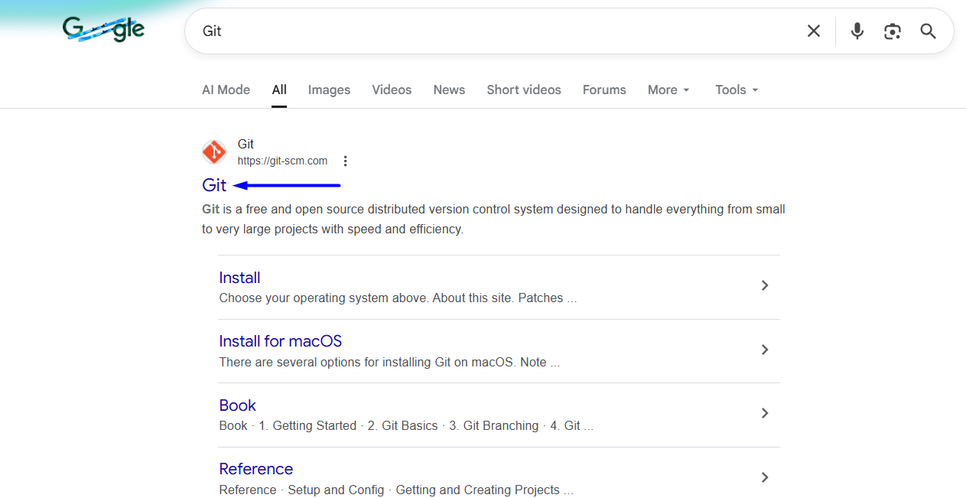
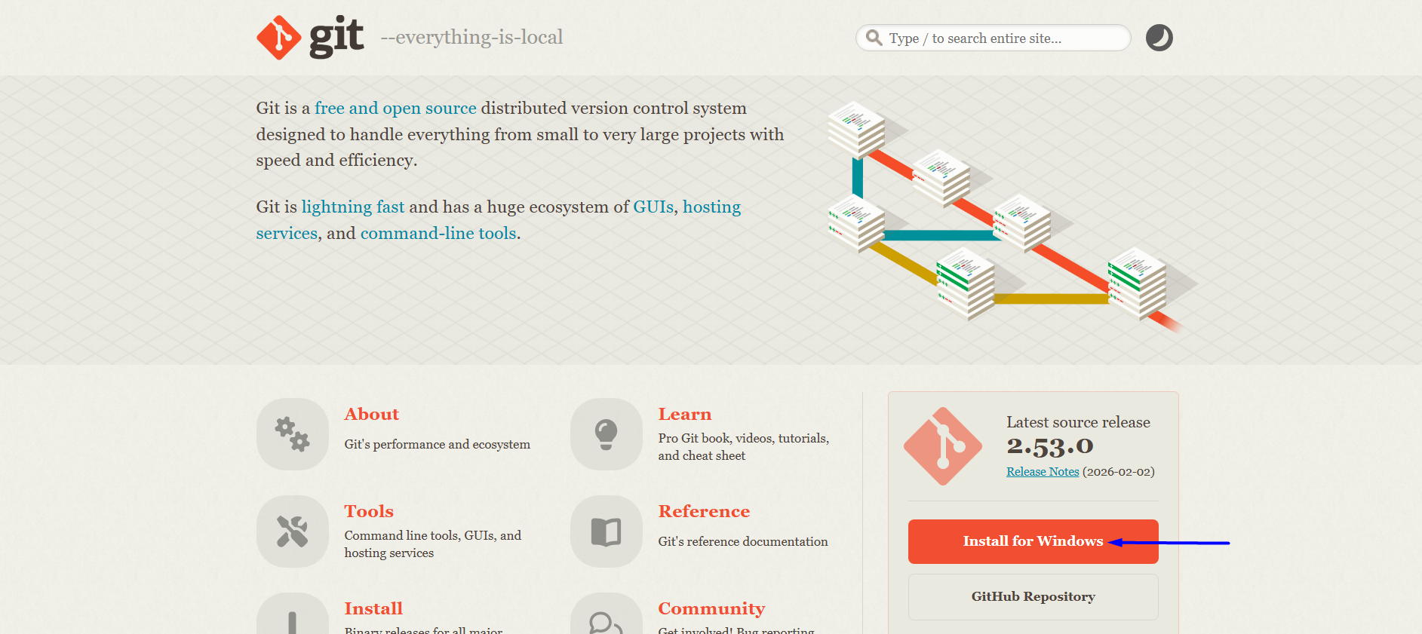
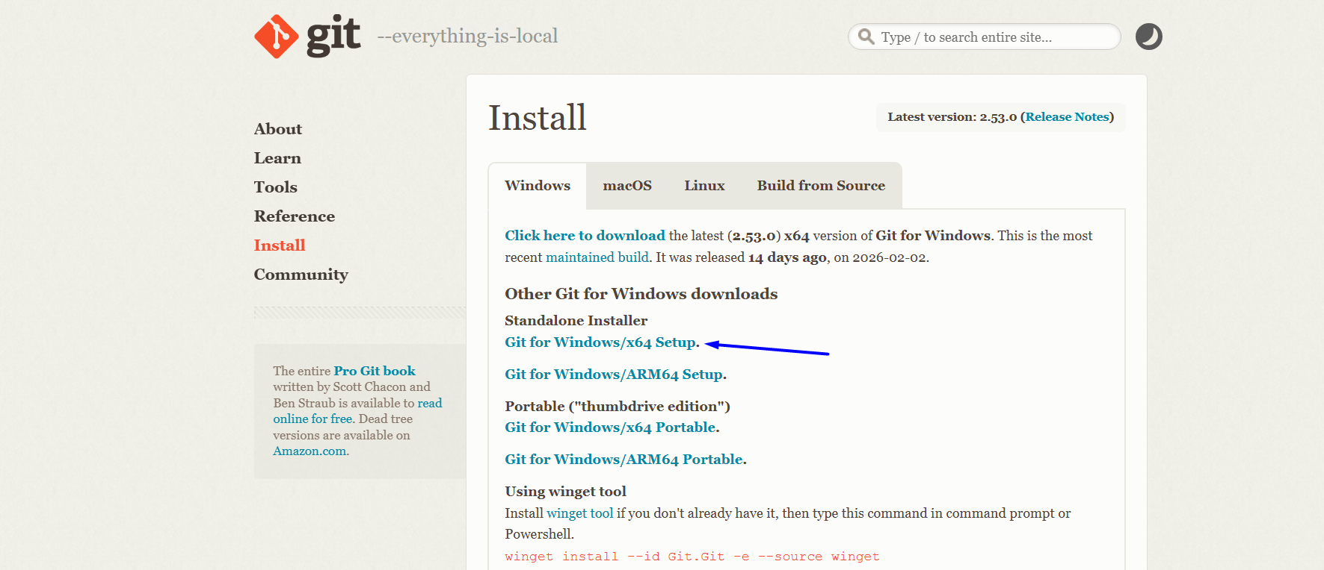
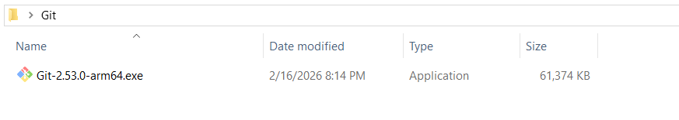

Install Git
# Source: ScreenShots Source: Provided by: [Persons Table -> ID Column: 1, Name_En Column: Motasem Essam] -> Tool: [Lightshot Program] -> From [Operating System: Windows] on [2/16/2026]
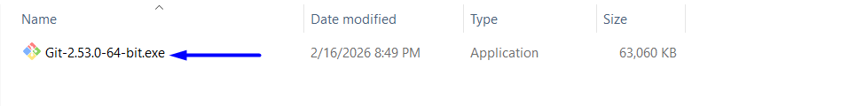

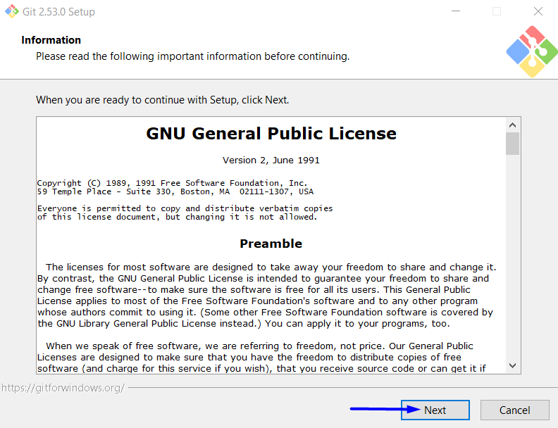
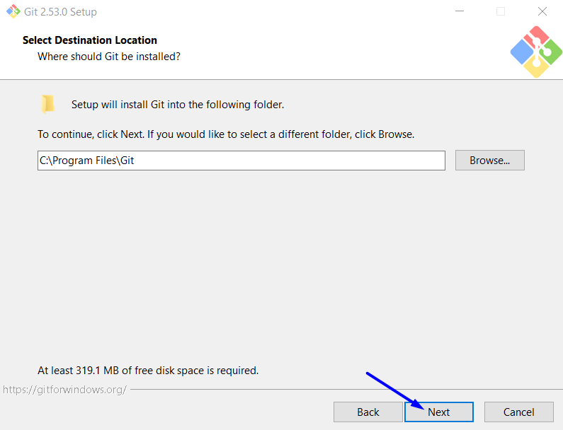
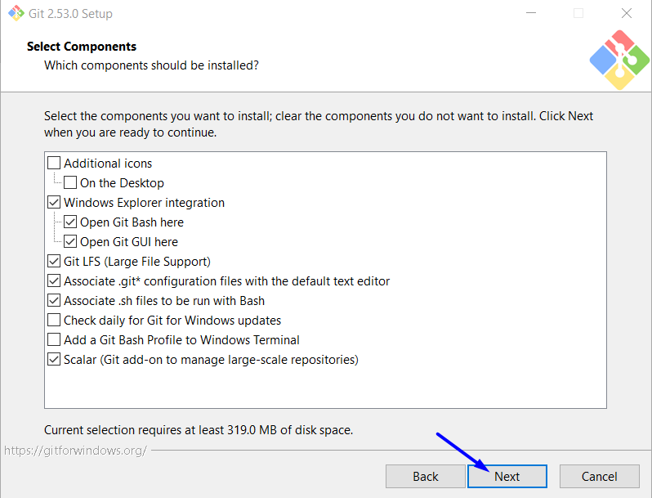
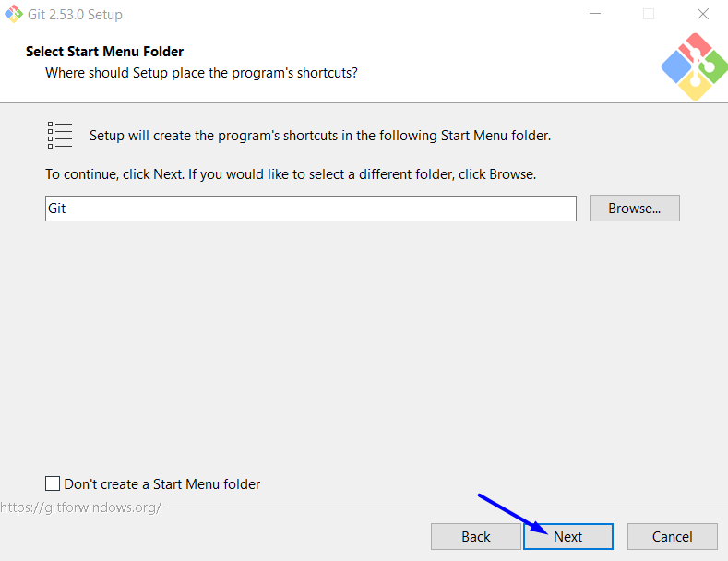
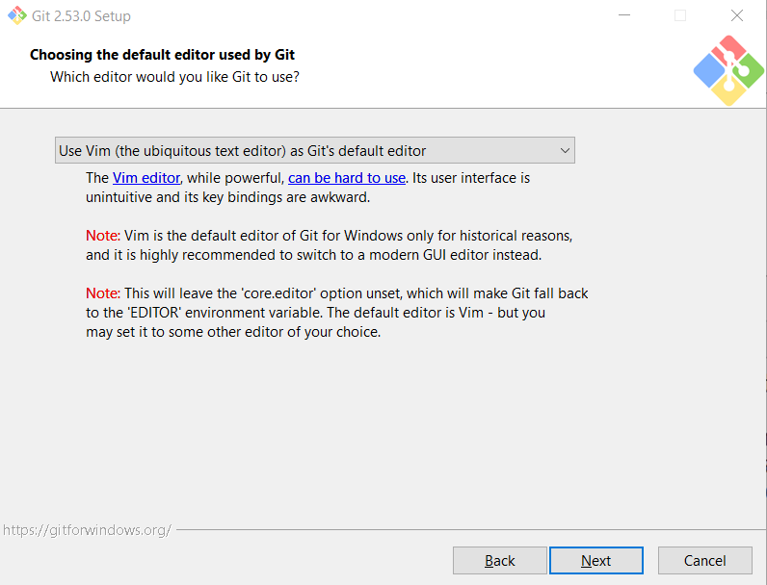
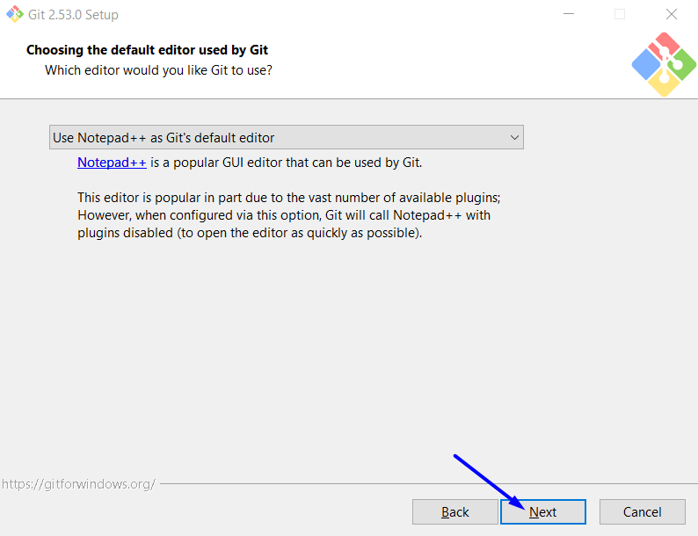
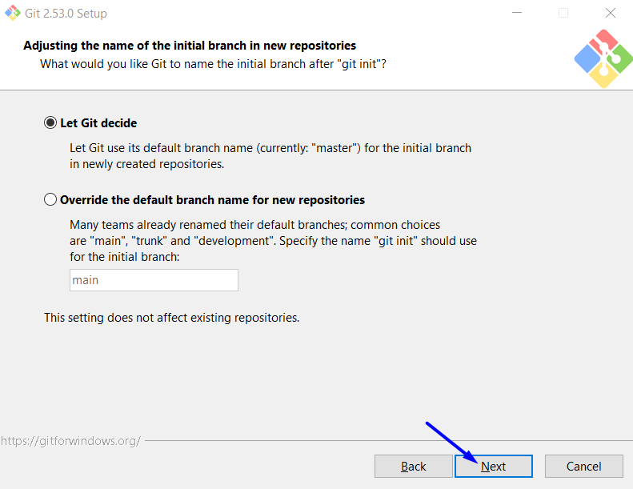
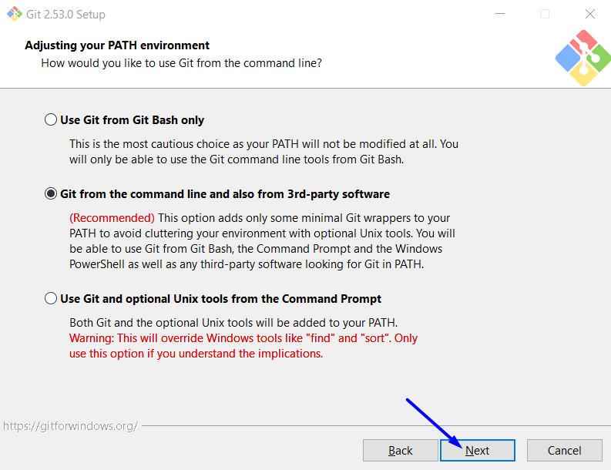
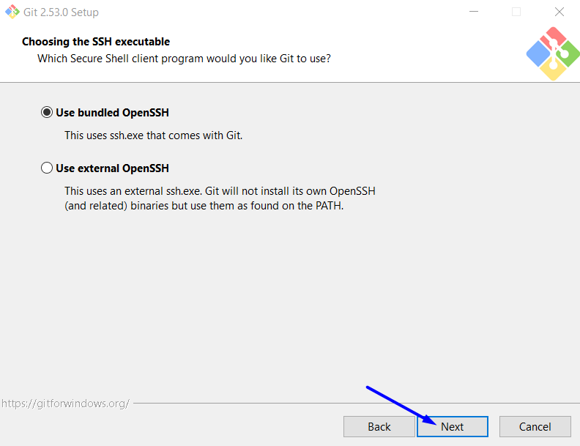
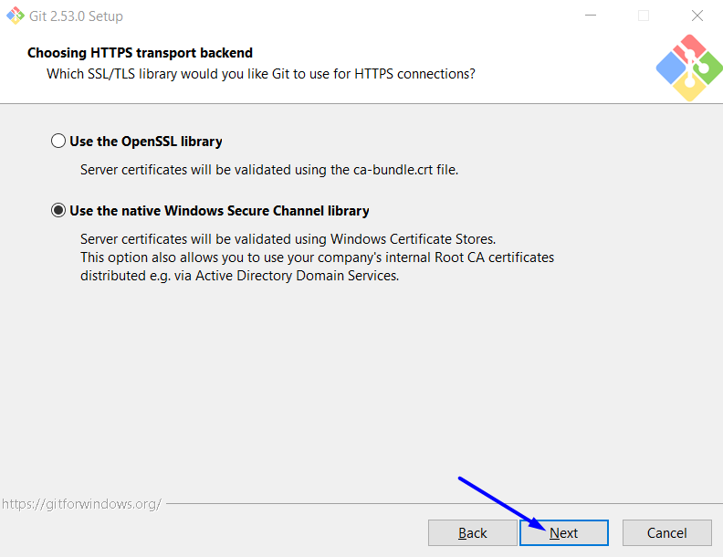
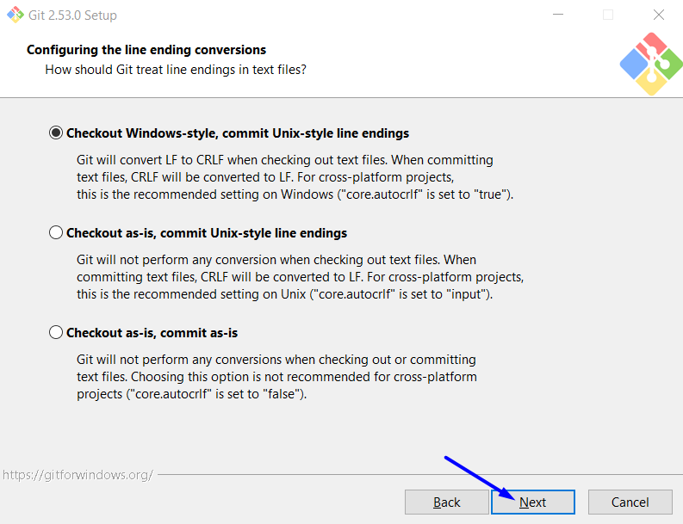

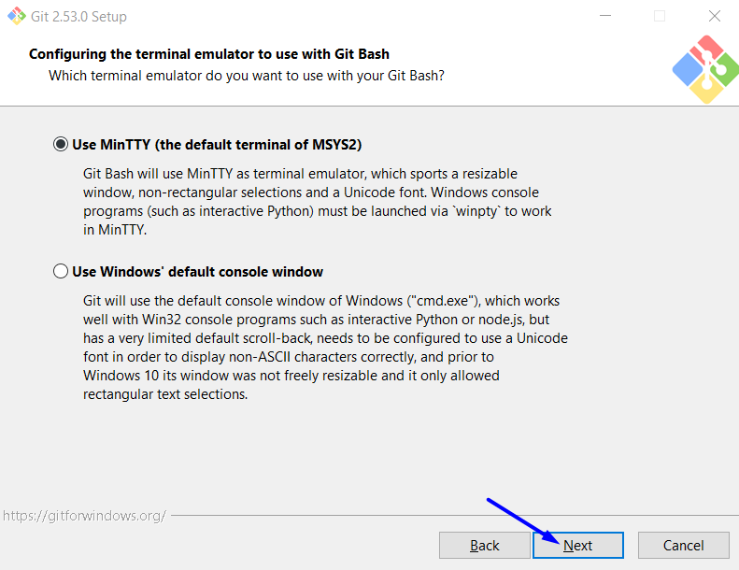
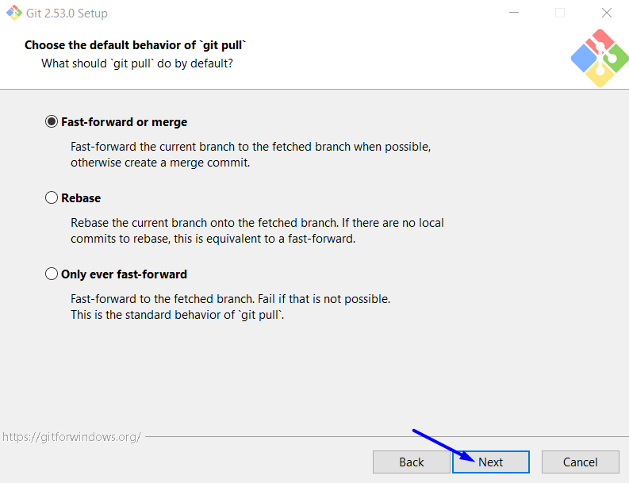
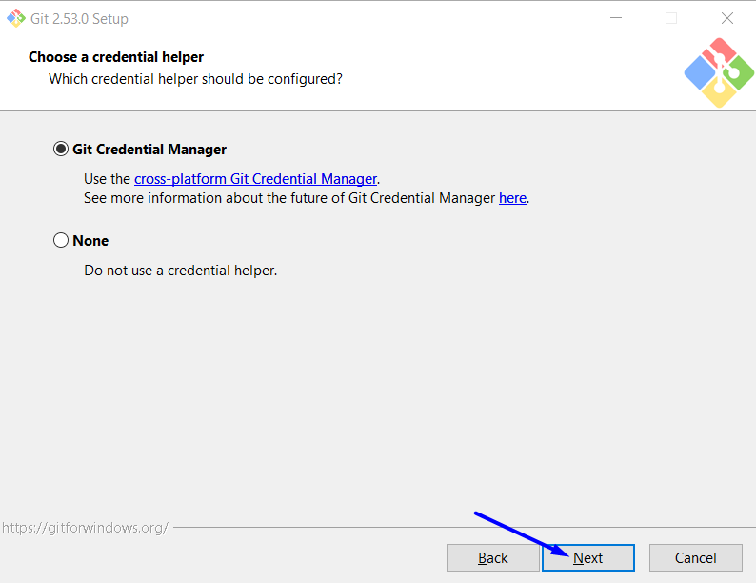
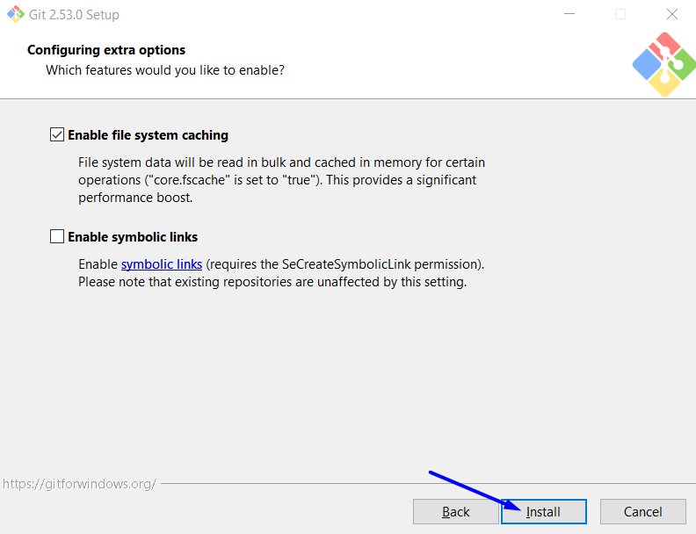
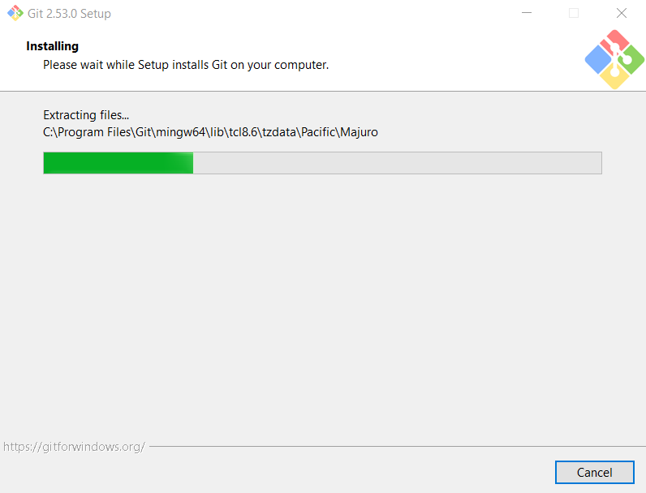
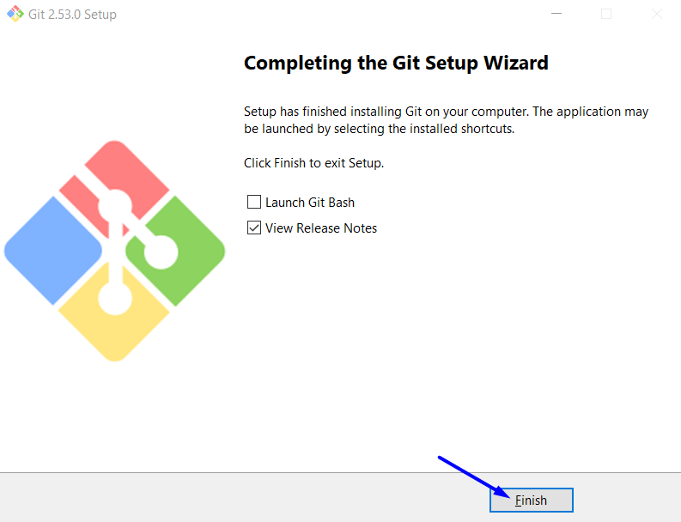

Git Bash

What is Git Bash
# Source: AI Source: Provided by: [Data Path: Persons Table -> ID Column: 1, Name_En Column: Motasem Essam] -> From: [ChatGPT] on [2/16/2026]
Git Bash is a command-line tool that lets you use Git and Linux/Unix commands on Windows.
In simple terms, it gives you a terminal (black window) where you can run Git commands like:
- git clone
- git add
- git commit
- git push
and also common shell commands like:
- ls (list files)
- cd (change directory)
- mkdir (create folder)
- rm (delete files)

What Git Bash includes
# Source: AI Source: Provided by: [Data Path: Persons Table -> ID Column: 1, Name_En Column: Motasem Essam] -> From: [ChatGPT] on [2/16/2026]
- Git – the version control system
- Bash shell – a Linux-style command interpreter
- Unix tools – basic commands that Windows normally doesn’t have

Why people use Git Bash
# Source: AI Source: Provided by: [Data Path: Persons Table -> ID Column: 1, Name_En Column: Motasem Essam] -> From: [ChatGPT] on [2/16/2026]
- Easier to follow Git tutorials (most use Bash commands)
- Powerful scripting and automation
- Same command style as Linux/macOS
- Better for developers than Windows Command Prompt

Example
# Source: AI Source: Provided by: [Data Path: Persons Table -> ID Column: 1, Name_En Column: Motasem Essam] -> From: [ChatGPT] on [2/16/2026]
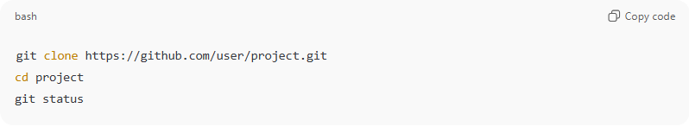
git clone https://github.com/user/project.git
cd project
git status
This downloads a project, enters the folder, and shows file status.

Run Git Bash
# Source: ScreenShots Source: Provided by: [Persons Table -> ID Column: 1, Name_En Column: Motasem Essam] -> Tool: [Lightshot Program] -> From [Operating System: Windows] on [2/16/2026]
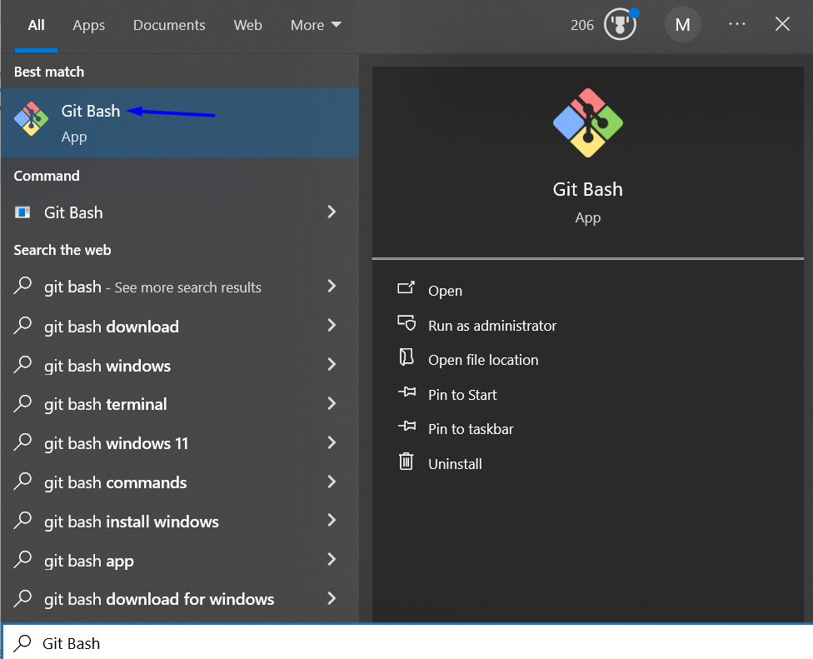
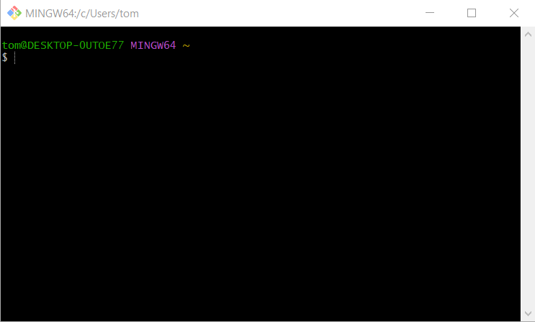
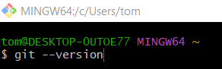
git --version
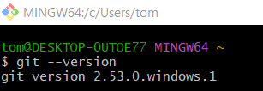

Git GUI

What is Git GUI
# Source: AI Source: Provided by: [Data Path: Persons Table -> ID Column: 1, Name_En Column: Motasem Essam] -> From: [ChatGPT] on [2/16/2026]
Git GUI (Graphical User Interface) is a visual application that lets you use Git without typing commands. Instead of using a terminal like Git Bash, you click buttons and menus to manage your repository.

What you can do with Git GUI
# Source: AI Source: Provided by: [Data Path: Persons Table -> ID Column: 1, Name_En Column: Motasem Essam] -> From: [ChatGPT] on [2/16/2026]
Using a Git GUI, you can:
- Create / clone repositories
- Stage files (add to commit)
- Commit changes
- View history and branches visually
- Merge branches
- Push / pull from remote repos (like GitHub)
- Resolve conflicts with visual tools

Simple example
# Source: AI Source: Provided by: [Data Path: Persons Table -> ID Column: 1, Name_En Column: Motasem Essam] -> From: [ChatGPT] on [2/16/2026]
Instead of typing:
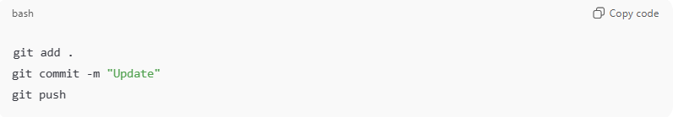
git add .
git commit -m "Update"
git push
In Git GUI you would:
- Check the changed files ✔
- Type commit message 📝
- Click Commit
- Click Push
No commands needed.

Popular Git GUI tools
# Source: AI Source: Provided by: [Data Path: Persons Table -> ID Column: 1, Name_En Column: Motasem Essam] -> From: [ChatGPT] on [2/16/2026]
Some common Git GUI apps are:
- Git GUI (comes with Git by default)
- GitHub Desktop – very beginner friendly
- Sourcetree – powerful and free
- TortoiseGit – integrates into Windows Explorer
- GitKraken – modern and visual (some paid features)

Git GUI vs Git Bash
# Source: AI Source: Provided by: [Data Path: Persons Table -> ID Column: 1, Name_En Column: Motasem Essam] -> From: [ChatGPT] on [2/16/2026]
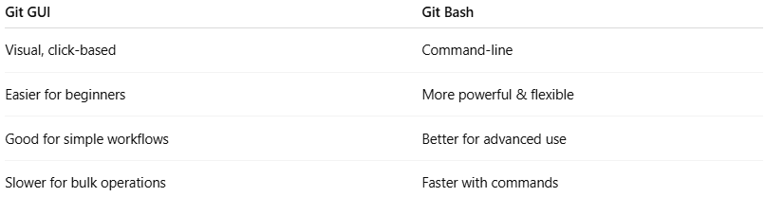
Git GUI | Git Bash
Visual, click-based | Command-line
Easier for beginners | More powerful & flexible
Good for simple workflows | Better for advanced use
Slower for bulk operations | Faster with commands

Run Git GUI
# Source: ScreenShots Source: Provided by: [Persons Table -> ID Column: 1, Name_En Column: Motasem Essam] -> Tool: [Lightshot Program] -> From [Operating System: Windows] on [2/16/2026]
